**Name : Intan Citra Phonskaningtyas**

**NRP : 06211940000007**

**Course : Exploratory Data Analysis C**

# Link Dataset

<https://www.kaggle.com/sansuthi/asian-countries-by-population>

<https://www.kaggle.com/shivamb/netflix-shows>

# Plot

## Count Plot

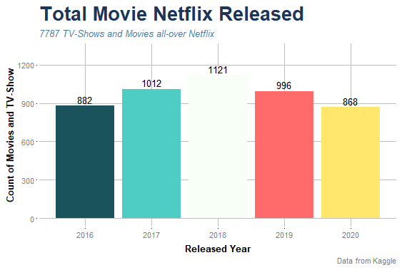

## Bubble Plot

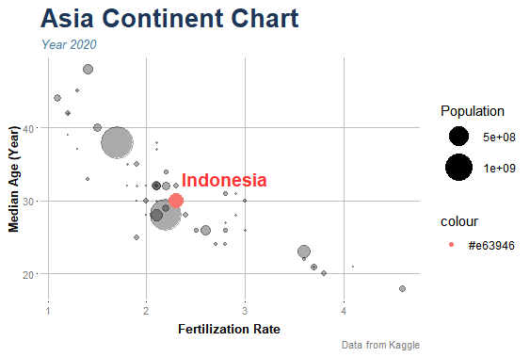

Thx.